Educational Visits Policy and SOP  Mandatory Read for school.  2.0 | 
Lead Director  Melanie Burrough, Director of Education and Therapies | Date Reviewed  November 2025
Lead Author(s)  Launa Randles, Head Teacher | Date Drafted  November 2025
Criterial Readers  Ish Harris  Keren Holding  Lauren Burtenshaw  Robin Bertrand  Elaine Lush | December 2025
Recommended By  Department for Education | Endorsed Date
Approved By  Educational Governance Committee | Ratified Date  March 2026
Published Date | Next Review Date  March 2028

Contents

Policy

Purpose and Objectives

Scope

Definitions

Stakeholder Consultation

Related Policies

External References and Guidance

Standard Operating Procedure (SOP)

Roles and Responsibilities

Process/ Procedure

Document Change Control

Appendices

Appendix 1 - Stakeholder Engagement Checklist

Appendix 2 – Onsite Risk Assessment

Appendix 3 – Risk assessment – A

Appendix 4 – Risk Assessment – B

Policy

Purpose and Objectives

The purpose of this policy is to define the procedures and responsibilities that ensure all pupils have access to safe, enriching experiences beyond the classroom. Educational visits provide real-world opportunities to engage with community life, enabling pupils to thrive and flourish in their learning.

The objectives of the policy and this procedure are to:

- Establish and assign clear accountability from the planning through to the educational visit and evaluating trip/visit.
- Support educational professionals to meet the needs and EHCP objectives for the children and young people.
- Ensure that all colleagues are aware of their individual responsibilities for each stage of the educational visit.
- Comply with regulations outlined in DfE health and safety on educational visits 2018
- Manage the risk of the educational visit being proportionate and sensible, focusing on how to manage genuine risk.

Relevant laws/ guidance and regulations include but are not limited to:
- DfE Health and Safety on Educational Visits 2018
- Keeping Children safe in Education 2025
- Working Together to safeguard Children 2023
- Health and Safety at work Act 1974
- Mental Capacity Act 2005

Scope

This policy applies to:

All colleagues across The Children’s Trust school

This policy does not apply to:

Travel Risk assessments- this will be covered in The Travel Risk Assessment Standard Operating Procedure (SOP)

Arranged medical or hospital appointments

Family led offsite visits

Siblings of children/ young people accessing children and family services

Definitions

Unless otherwise stated, the words or expressions contained in this document shall have the following meaning:

TCT  TCT SCH | The Children’s Trust  The Children’s Trust School
SOP  CYP  DSL  Routine internal visit  External educational visit | Standard Operating Procedure  Children and Young People  Designated Safeguarding Lead  Educational lessons in a different TCT location/grounds  Educational trips that need a risk assessment and extra planning
EHCP  DSL  MTP | Education, Health, Care plan  Designated safeguard Lead  Medium Term Planning
Outing Leader | Each outing will have a designated Leader, this may or may not be the teacher. The Leader will have the relevant experience to take responsibility for the children, staff, volunteers and family members going on the outing. The leader should not be responsible for the 1:1 care of a child during the outing.

4. Stakeholder Consultation

Appendix 1 details the stakeholders who were consulted in the development of this policy and SOP

5. Related Policies and Procedures

The following policies and procedures stated below support the effective application of this policy and SOP:
- Child Protection and Safeguarding Policy
- Missing Children Guideline Policy
- Transport Driver’s Policy
- Outings Policy & SOP 2023
- Food Safety Policy
- Travel risk Assessment
- Equality, Diversity and Inclusion Policy

External References and Guidance

The following external resources and guidance were consulted in drafting this policy and SOP:

- Supporting people with profound and multiple learning disabilities Core & Essential Service Standards
- IMPACTs curriculum
- Learning Outside the Classroom Quality Badge LOtC

Standard Operating Procedures (SOP)

Roles and responsibilities

- Headteacher / Chair of Governors

- Ultimate responsibility for all educational visits.
- Ensure inclusivity and insurance coverage.

- Headteacher with DSL Educational Visit Co-ordinator

- Give approval for local and day educational visits.
- Ensure that all staff (including volunteers) are appropriately trained, experienced and briefed. (Includes emergency protocols / fist aid / medication/ child protection & safeguarding)
- Ensure that the visit is appropriate for the suggested group of pupils and has educational value.
- Ensure that all appropriate risk assessments have been undertaken and all relevant paperwork is completed & signed prior to visit.
- Acts as the contact point for the school on any issue.

- Outing Leader (Teacher / Senior STA / Play & leisure team)

- Through school planning (MTP) identify rationale for visit
- Take overall responsibility for planning and organising the educational visit.
- Collect parental consent (if required)
- Complete required risks assessments and note any contingency plans. (Includes IRAR risk assessment –School Education A (one week prior to visit / B on day of visit or onsite education visit – appendices 2-4)
- Take overall charge of staff, volunteers and pupils during the visit.
- All staff are up to date with the child’s care plan (medical / behavioural / individual risk assessments)
- During visit have access (by phone) to school contacts (Headteacher / deputy head/ school Lead Nurse/ DSL)
- Contact the school in the event of any emergency or problem to obtain further advice.
- Capture evidence from educational visit video / photo (for those with consent)
- Record attendance
- Ensure CYP have appropriate clothing
- Evaluate visit to inform future planning.

- School Nurse
- In collaboration with outing leader ensure the child has the equipment, staff with required competencies for the educational visit. This includes: -
- Adequate supplies for personal care needs
- All relevant medication and emergency medication along with the most recent copies of the drug charts and emergency protocols
- A copy of the up to date, relevant, Emergency transfer letter

- TCT Transport
- TCT Trust vehicles and ensuring the vehicles are maintained.
- Driver
- Transporting passengers safely.
- Pass The Children’s Trust’s ‘Driver the Trust’s Vehicles’ and ‘vehicle safety equipment training’.
- Completed Occupational Health medical to drive a Children’s Trust Vehicle
- All chairs and car seats are securely clamped.
- Operating the tail lift when loading and unloading
- Park with the blue disability badge displayed correctly.
- Maintain vehicle cleanliness.
- Report any incidents or concerns about the vehicle to transport team.

Process/ Procedure – onsite educational visit

Use onsite location/environments to ensure each visit has clear education objectives which are appropriate to the children and young people.

Identify visit on medium- and short-term plans.

Complete onsite checklist – appendix 2

Leave via front entrance of building with walkie talkie.

Record learning outcomes / consider informing families via class DOJO.

Process/ Procedure – offsite educational visit

6 weeks + before visit

Research suitable educational visit to ensure each visit has clear educational objectives which are appropriate to the children and young people.

Identify educational visit on medium term plan with any financial costs.

4 weeks before visit

Complete risk assessment (master OUTM001 updated with specific detail)

Check transport needs of individuals.

Seek approval for visit (includes approval on IRAR risk assessment) from the Head teacher or Deputy Head

Book transport (may include volunteer driver)

Obtain necessary consent for the visit

Communicate information in school/house diaries.

Order food and inform the school lunchtime co-ordinator

Work with the school nurse team to ensure child has equipment, staff with required competencies for the visit.

1 weeks before visit

Complete the School Educational visit form section A

Seek approval signature for section A – appendix 3

Day of visit

Complete the School Educational visit form section B

Seek approval signature for section B – appendix 4

Leave section B at school reception.

After visit

Any incident to be reported to the Headteacher/DSL and recorded

Record educational outcomes/ impact of visit.

Evaluate educational visit to inform future planning.

Document Change Control

Version | Status | Description (of changes) | Reviewed by | Reviewed/ Issued Date
0.1 | Draft | Education visit extracted from Trust Outings Policy to meet the education requirements | Launa Randles | Jan 2023
0.2 | Draft | Included reference to Transport Policy | Mark Davies | Feb 2023
1.0 | Final | Ratified at EGC | EGC | 2023
1.1 | Draft | Reviewed and changed against update in KCSIE 2025 and WT23. Checked against the update of OUTINGs policy. Removal of the platform ‘IRAR’ |  | October 2025
2.0 | Final | Ratified at EGC | EGC | March 2028

Appendix 1 – Stakeholder Engagement Checklist

Review and complete the following checklist to indicate which stakeholders were consulted in the development of this policy.

# | Question | Yes/ No | Stakeholder(s) to be consulted
1 | Is there a statutory requirement to have in place this particular policy/ does the policy need to comply with detailed legislation? | Y | DfE guidance
2 | Is implementation of the policy (or any element of it) dependent on the use of new or existing information technology? | N
3 | Does implementation of the policy (or any element of it) place any demands on/ or affect the activities of the Estates and Facilities teams (e.g. does it impact the provision or maintenance of premises, equipment, vehicles or other TCT assets)? | Y | Transport
4 | Does implementation of the policy or any element of it involve/ impact the processing of personal data? | N
5 | Does implementation of the policy require significant unbudgeted operational or capital expenditure? | N
6 | Does implementation of the policy (or any element of it) directly or indirectly impact on the delivery of services / activities in other areas of the organisation? E.g. a policy written by a clinical lead in CF&S might impact on the delivery of care for CYP attending the School. | Y | Play team.  Therapy
7 | Is there a need to consider Health and Safety or potential environmental impacts in developing and implementing the policy? | Y | Health and Safety Manager
8 | Have you consulted with a representative of those who will be directly impacted by the policy? | Y
9 | Is there a need to consider Equity, Diversity and Inclusion in developing and implementing the policy? | N | Statement is within policy
10 | Is there a need to consider sustainability and potential environmental impacts in developing and implementing the policy? | Y | Captured on risk assessment
11 | Please detail any other stakeholder groups consulted, if applicable. | Y | School Nurse team / teachers / enrichment leads

Appendix 2 Onsite – education visit

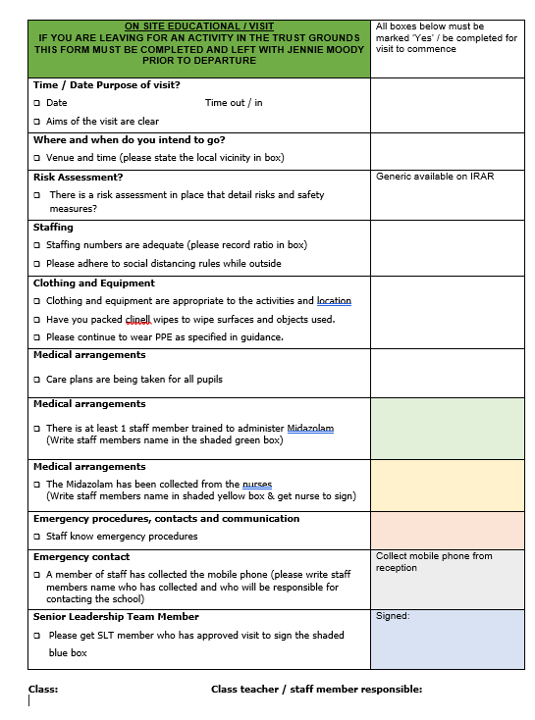

Appendix 3 – one week prior to visit

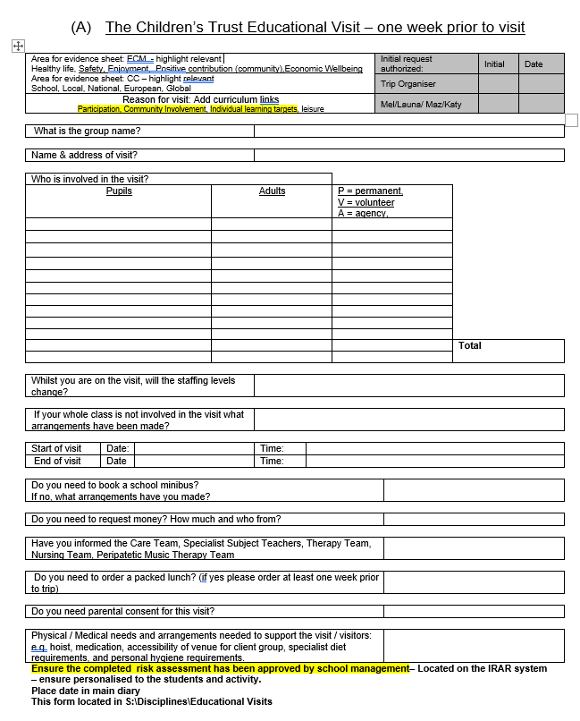

Appendix 4 – on day of visit

